CREATED FOR rYA NORTHERN IRELAND

The Athlete Brand & Sponsorship program

workbook #1

Presented by the brand builders

# 

## Introduction to the program

Welcome to the RYA Athlete Brand and Sponsorship Program, presented by The Brand Builders.

This program will teach you how to build your unique brand and leverage it for social media and sponsorship opportunities.

You will take part in five online sessions between February – May of 2024. Each session will cover a different topic and equip you with the knowledge, skills and tools needed to bring your brand to life.

All workbooks, session recordings and updates to the program will be posted on the Program Hub which you can access [HERE.](https://www.thebrandbuilders.com.au/rya-northern-ireland-program-page/)

**PROGRAM SCHEDULE**

|  |  |  |
| --- | --- | --- |
| **Session** | **Date** | **Zoom Link** |
| #1 Build Your Brand | Wed 07 Feb  7.30 – 8.30pm | https://zoom.us/j/5806507910 |
| #2 Communicate Your Brand on Social Media | Wed 28 Feb  7.30 – 8.30pm | https://zoom.us/j/5806507910 |
| #3 Creating Content for Social Media | Wed 20 March  7.30 – 8.30pm | https://zoom.us/j/5806507910 |
| #4 Sponsorship (Part 1) | Wed 10 April  7.30 – 8.30pm | https://zoom.us/j/2206846834 |
| #5 Sponsorship (Part 2) | Wed 01 May  7.30 – 8.30pm | https://zoom.us/j/2206846834 |

## Introduction to session #1: build your brand

We are looking forward to meeting you at the first session, where we will kick start your brand journey by building the foundations of your brand.

**During this session you will learn:**

* What brand is and what makes a strong athlete brand
* Why brand matters for you and the value it holds
* How to identify your unique athlete brand
* How athletes (of all types, sports, levels, ages) have built and leveraged their brand

In each session you will complete some fun activities that will help you build and leverage your brand. All activities can be found and completed in your workbook. Please keep it handy during the session.

**What’s in this workbook:**

You will find the following resources in this workbook:

**Activity #1** Athlete Brand Blueprint

**Activity #2** Create Your Brand Vision

**Activity #3** Athlete Brand Snapshot (optional homework activity)

## ACTIVITY #1 Athlete BRAND BLUEPRINT

Identify the key elements of your unique brand!

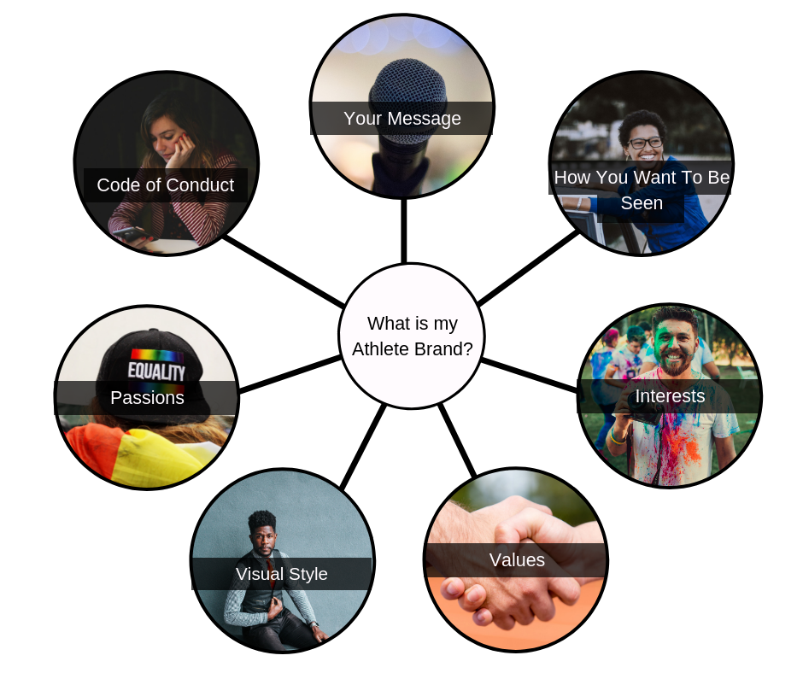

**Athlete Brand Elements**

* Interests
* Passions
* Values
* Visual Style
* Code of Conduct
* How You Want to be Seen
* Message

Write 3-5 things for each brand element.

|  |  |
| --- | --- |
| **Interests** |  |
| **Passions** |  |
| **Values** |  |
| **Visual Style** |  |
| **Code of Conduct** |  |
| **How You Want to be Seen** |  |
| **Message** |  |

## ACTIVITY #2 Brand vision

Identify your vision for your brand.

|  |  |
| --- | --- |
| **Vision Pillar** | **Your Vision Statement** |
| **What would you love your brand to help you achieve?**  E.g. Get sponsored, start my own business, get better at social media. |  |
| **What skills would you like to develop by building your brand?**  E.g. Communication, public speaking, social media. |  |
| **Who would you love to help, inspire or motivate by building your brand?** E.g. Inspire other women in sport. |  |

## ACTIVITY #3 instructions: athlete brand snapshot

This is an optional activity you can complete after the session to help you create a snapshot of your brand elements.

This activity will help you bring your brand elements together into a centralised snapshot, making it easier for you to communicate your brand quickly and clearly.

You’ve already done the hard by identifying your brand elements, so this isn’t about coming up with new ideas. Instead, this is your first chance to have a go at communicating your brand and bringing it all together.

**How to complete the activity**

1. Write down the IMPRESSION you want to leave. How do you want people to remember you? Look back at your brand elements and see if there are any consistent themes or words.
2. Write down the IMPACT you want to create. What do you want to be remembered for having done? Look back at your brand elements (particularly your passions, interests and message) and think about who you want to help or inspire or anything you want to be remembered for having achieved/done. E.g. inspiring women in sport, being an advocate for sustainability, motivating people to chase their own dreams.
3. From here, you can combine your impact and impression into one statement. This step is optional.

Go to the next page to complete the activity.

## activity #3 athlete brand snapshot

Complete the activity below.

**The Impression I Leave**

E.g. “I am an empathetic leader, a chatterbox and a style-loving athlete that takes a creative approach to everything I do.”

|  |
| --- |
|  |

**The Impact I Will Create**

E.g. “I want to change the narrative of women’s sport. I want to be remembered for showing the world we are exceptional high-performers and noisemakers.”

|  |
| --- |
|  |

**Putting It All Together**

Combine your Impression and Impact statements to create a single snapshot of your brand. E.g. “I am a leader, chatterbox and style-loving athlete that is on a mission to change the narrative of women’s sport.”

|  |
| --- |
|  |