CREATED FOR rYA NORTHERN IRELAND

The Athlete Brand & Sponsorship program

workbook #4

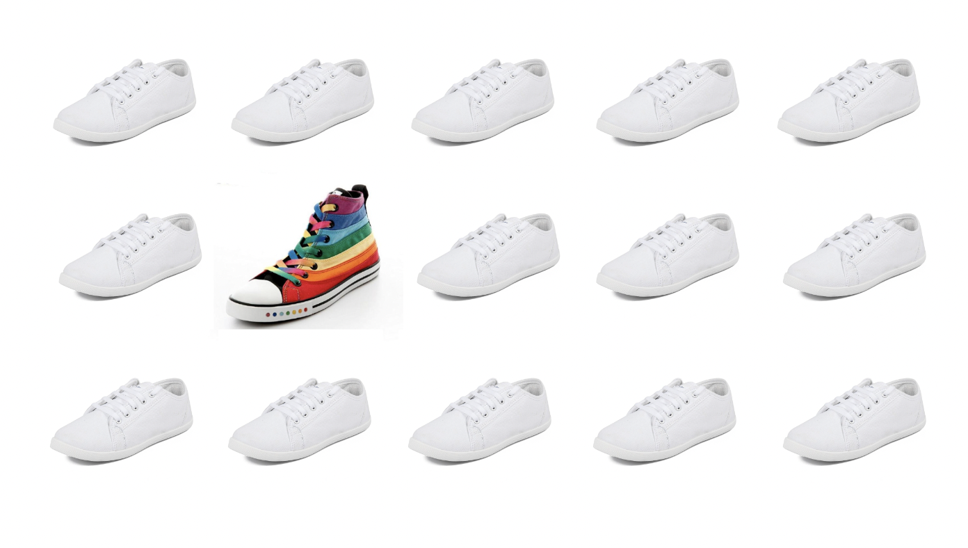Presented by the brand builders

**INTRODUCTION TO THE PROGRAM**

Welcome to the RYA Athlete Brand and Sponsorship Program, presented by The Brand Builders.

This program will teach you how to build your unique brand and leverage it for social media and sponsorship opportunities.

You will take part in five online sessions between February – May of 2024. Each session will cover a different topic and equip you with the knowledge, skills and tools needed to bring your brand to life.

All workbooks, session recordings and updates to the program will be posted on the Program Hub which you can access [HERE.](https://www.thebrandbuilders.com.au/rya-northern-ireland-program-page/)

**PROGRAM SCHEDULE**

|  |  |  |
| --- | --- | --- |
| **Session** | **Date** | **Zoom Link** |
| #1 Build Your Brand | Wed 07 Feb  7.30 – 8.30pm | https://zoom.us/j/5806507910 |
| #2 Communicate Your Brand on Social Media | Wed 28 Feb  7.30 – 8.30pm | https://zoom.us/j/5806507910 |
| #3 Creating Content for Social Media | Wed 20 March  7.30 – 8.30pm | https://zoom.us/j/5806507910 |
| #4 Sponsorship (Part 1) | Wed 10 April  7.30 – 8.30pm | https://zoom.us/j/2206846834 |
| #5 Sponsorship (Part 2) | Wed 01 May  7.30 – 8.30pm | https://zoom.us/j/2206846834 |

## Introduction to session #4: Sponsorship part 1

It’s time to get sponsorship ready!

**During this session you will learn:**

* How to identify what you want and need from sponsors
* Identify what you can offer sponsors
* Create a list of potential sponsors
* Choose a target sponsor to approach

In this session you will complete some practical activities to get you ready to approach a target sponsor! All activities can be found and completed in your workbook. Please keep it handy during the session.

**What’s in this workbook:**

You will find the following resources in this workbook:

**Activity #1** Identify Your Sponsorship Needs

**Activity #2** Identify the Value You Can Offer Sponsors

**Activity #3** Identify Potential Sponsors

## ACTIVITY #1 Identify Your Sponsorship needs

You can use a blank piece of paper first or write your list straight in here (we’ve put some examples in just so you can see how to use the template…feel free to delete them once you’re ready to start!)

**There are 2 different forms of value you can seek from sponsorship:**

* Monetary – financial, products, services etc anything that has a monetary value.
* Personal – grows your profile, develops skills, fulfills you emotionally, offers opportunities etc.

It’s good to have a mix of the types of value you gain from your sponsor, as it means overall the relationship is more valuable for you and also has a greater level of substance to it.

**Tick up to 3 things in each category which you would like to get from being a sponsored athlete.**

|  |  |  |  |  |  |  |  |  |  |  |  |  |  |  |  |  |  |  |  |  |  |  |  |  |  |  |  |  |  |
| --- | --- | --- | --- | --- | --- | --- | --- | --- | --- | --- | --- | --- | --- | --- | --- | --- | --- | --- | --- | --- | --- | --- | --- | --- | --- | --- | --- | --- | --- |
| |  |  | | --- | --- | | **Monetary Value** | Checkbox Ticked with solid fill | | Cash |  | | Products |  | | Services |  | | Memberships |  | | Subscriptions |  | | Other - |  | | |  |  | | --- | --- | | **Personal Value** | Checkbox Ticked with solid fill | | Grow my profile |  | | Gain experience of being sponsored |  | | Develop my skills |  | | Grow my network |  | | Gain confidence |  | | Other - |  | |

## ACTIVITY #2 Identify the value you can offer sponsors

Identify all the ways you would like to offer value to your sponsor/s. Don’t worry about the details just yet. This is just an initial exploration of potential!

Feel free to add your own ideas in the blank rows provided in each category.

|  |  |  |
| --- | --- | --- |
| **CATEGORY** | **MAIN CATEGORY** | **‘YES’** |
| **Staff Wellbeing and Engagement** | Keynote Presentation – Your story or a valuable message / topic. |  |
| Motivation presentations – Telling your story, the highlights, lowlights |  |
| Teambuilding workshop – It could be a sports activity or something as simple as a Walk n Talk session – Lunchtime walking, shared experience of how exercise makes us feel better, emotionally and physically |  |
| Ongoing or One Off Fitness Session E.g. to prepare for a Challenge or Event |  |
| 1-1/small group coaching, mentoring or motivation sessions for staff |  |
| Fun/family days (staff and/or clients) – mini obstacle course-kids variety activities-parent/child competitions, etc |  |
| Participate in your sport e.g. a sailing day, AFL skills session etc |  |
| Provide or co-develop educational/informational resources and content e.g. healthy recipes, activity and wellbeing tips, training plans etc |  |
| **Education and Facilitation** | Health coach/ambassador (in person online) |  |
| Motivation presentations – Telling your story, the highlights and the lowlights |  |
| Ongoing or One Off Fitness Session – Could be in preparation for a Challenge or Event |  |
| Teambuilding workshop – It could be a sports activity or something as simple as a Walk n Talk session – Lunchtime walking, shared experience of how exercise makes us feel better, emotionally and physically |  |
| Workshop hosting on topic of your expertise e.g. time management, creative thinking etc |  |
| **Product Research and Development** | Product testing and feedback |  |
| Written reviews for use by sponsor in various media (social, print, radio, newsletters, websites, blogs) |  |
| Images provided with product/service in use by you |  |
| Video reviews and testimonials |  |
| Engagement of others of the products/service tested (other athletes/mums/local residents/my fitness clientele/sporting clubs) |  |
| Signature/co-branded product or range e.g. Sarah Smith sport bag range |  |
| **Business Development** | Attend instore activations, product launches and product training sessions |  |
| Introductions to team/club/organisation members e.g. networking |  |
| Help identify marketing and promotional activities, such as seminars |  |
| Attend special events i.e. expos, conferences, award presentations |  |
| Connect your sponsors with events where they can be involved in hospitality, product sampling and giveaways and awards. |  |
| Access to discounts, merchandise etc through other sponsorship relationships |  |
| **Social Impact and Community Engagement** | Representing your sponsors and/pr attending with them: |  |
| * Sports Events / Races |  |
| * Sports participation / Come and Try (sport) days |  |
| * Info / Open Days |  |
| * Charity/sponsored events |  |
| * Community Networking Events |  |
| * Fundraising events |  |
| Collaborate with your sponsors charity of choice – offer your value to them for awareness raising, fundraising, something they can auction off/give as prize, or event participation |  |
| Dedicating your race as a fundraiser for their charity of choice |  |
| **Social Media and Communications** | Product reviews |  |
| Co-create content together e.g their educational or promotional videos featuring you |  |
| Create unique content for sponsor including branded photos and videos |  |
| Product / Services in use in amazing places around the world (NZ, Australia, The Himalayas) |  |
| Logo placement – clothing, website, book, media release, photos and videos, get creative with signage and clothing. |  |
| Testimonials – written, photographs, videos |  |
| Testimonials – shared on social media, with media and/or provided to sponsor for use across all online and print platforms |  |
| Be the ‘face of’ a campaign or the company itself |  |
| Modelling in catalogue / website / advertising photo shoots |  |
| Sharing your story / journey as part of a customer engagement campaign |  |
| Feature in advertising/marketing campaigns (print/radio/online) |  |
| Corporate speaking captured as content for socials |  |
| Promoting events (social media and word of mouth) |  |
| Product endorsement |  |
| Use of sponsors logo, trademark or images for website or social media |  |
| Blog content including XYZ Company endorsement, product reviews and recipe ideas |  |
| Write content for their website, blog or newsletter |  |
| Offer to host competition on your social media i.e. get your followers to….win a product by LIKING sponsors page |  |
| Product placement / promotional posts in natural, non-salesy way |  |
| Offer increased audience to sponsors through your combined network |  |
| Inclusion of logo or product in your regular posts i.e. your weekly tips |  |
| Increase network via tagging sponsors in posts |  |
| Images of logo promoted at pre and post (podium) events |  |
| Posting recipes and cooking and nutrition tips |  |
| Posting training tips |  |
| Regular newspaper article/column – local paper |  |
| Communication program for sponsor’s market – consumer or trade |  |
| Banner or pull-through ads on the your website |  |
| Promotion or contest on your website and/or social platforms |  |
| Use of logos, images or trademarks on website, social media platforms |  |
| Invite sponsor to provide content in your marketing material i.e. newsletters |  |
| Make yourself available for media interviews |  |
| Inclusion in your media articles e.g. if you write articles for a website |  |
| Inviting sponsors to attend media interviews |  |
| Social media coverage of using products at events |  |
| Commentating at events |  |
| **Customer Engagement**  **And for a little fun….** | Attend instore activations, product launches and product training sessions |  |
| Interview/Q&A (online or in person) after a specific event/activity |  |
| Attend events to connect with customers e.g. races, expo/trade show, community days, etc |  |
| Social Media takeover with a customer focus e.g. that responds to them or involves them in some way |  |
| Be active on socials in comments sections |  |
| Create content that speaks to customers e.g. product reviews, tips, hacks etc |  |
| Competitions and challenges (online and in person) |  |
| Temporary tattoos on your torso/arms/legs etc of major sponsors logo on your event days |  |
| Offer unique branding opportunities on key project equipment with high visibility i.e. graffiti piece on your surfboard or boat with sponsor logo/colours/image etc |  |
| Provision of ‘web events’ created especially such as chat with sponsors or a Q & A session for their social media followers and customers |  |
| Viral-challenge incorporating sponsor product i.e. a watch used in a handstand challenge by gymnasts to time how long they can do a handstand. |  |
| Hospitality - tickets to event, tickets to corporate boxes, reserved seating etc |  |

## ACTIVITY #1 Identify potential sponsors

Here’s a few great ways to identify potential sponsors! Of course you could expand on each list, but for now we’re just choosing 1-3 in each category:

|  |  |  |  |
| --- | --- | --- | --- |
| **Category** | **#1** | **#2** | **#3** |
| **Sport Product** |  |  |  |
| **Sport Service** |  |  |  |
| **Sport Mship/subscription** |  |  |  |
| **Life Product** |  |  |  |
| **Sport Service** |  |  |  |
| **Sport Mship/subscription** |  |  |  |
| **Local Business** |  |  |  |
| **Local Business** |  |  |  |
| **Local Business** |  |  |  |
| **Connection/Contact** |  |  |  |
| **Wild ideas** |  |  |  |

*If you complete the above table that’s 30+ potential sponsors you’ve identified!

**STEP 2 - CHOOSE YOUR TARGET SPONSOR**

MY ONE TARGET SPONSOR (to continue this education program with)

____________________________________________________________________

**NEXT SESSION –** We will put this all together in a Sponsorship Snapshot and get you ready to go and approach your target sponsor!